Coude′ Auxiliary Telescope – CAT

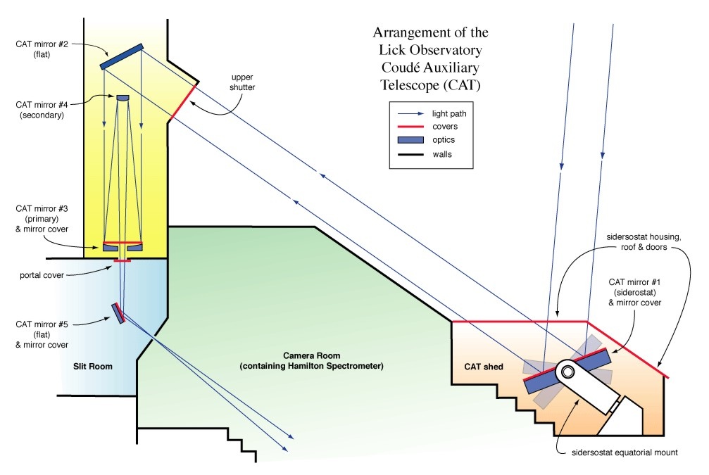

Optic # | Optic Notes | Procedures
#1 | SiO overcoated aluminum  Subjected to extreme moisture  Up facing mirror – Protective cover | Inspect and wash monthly
#2 | SiO overcoated aluminum  Subjected to moderate moisture  Down facing mirror – Protective enclosure | Inspect every 6 months  Wash as needed
#3 | SiO overcoated aluminum  Subjected to moderate moisture  Up facing primary mirror – Protective cover | Inspect monthly  Co₂ every other month  Wash as needed
#4 | SiO overcoated aluminum  Subjected to moderate moisture  Down facing secondary mirror | Inspect every 6 months  Wash as needed
#5 | Unsure of coating  Up facing mirror – Protective cover | Inspect monthly  Remove & wash as needed

